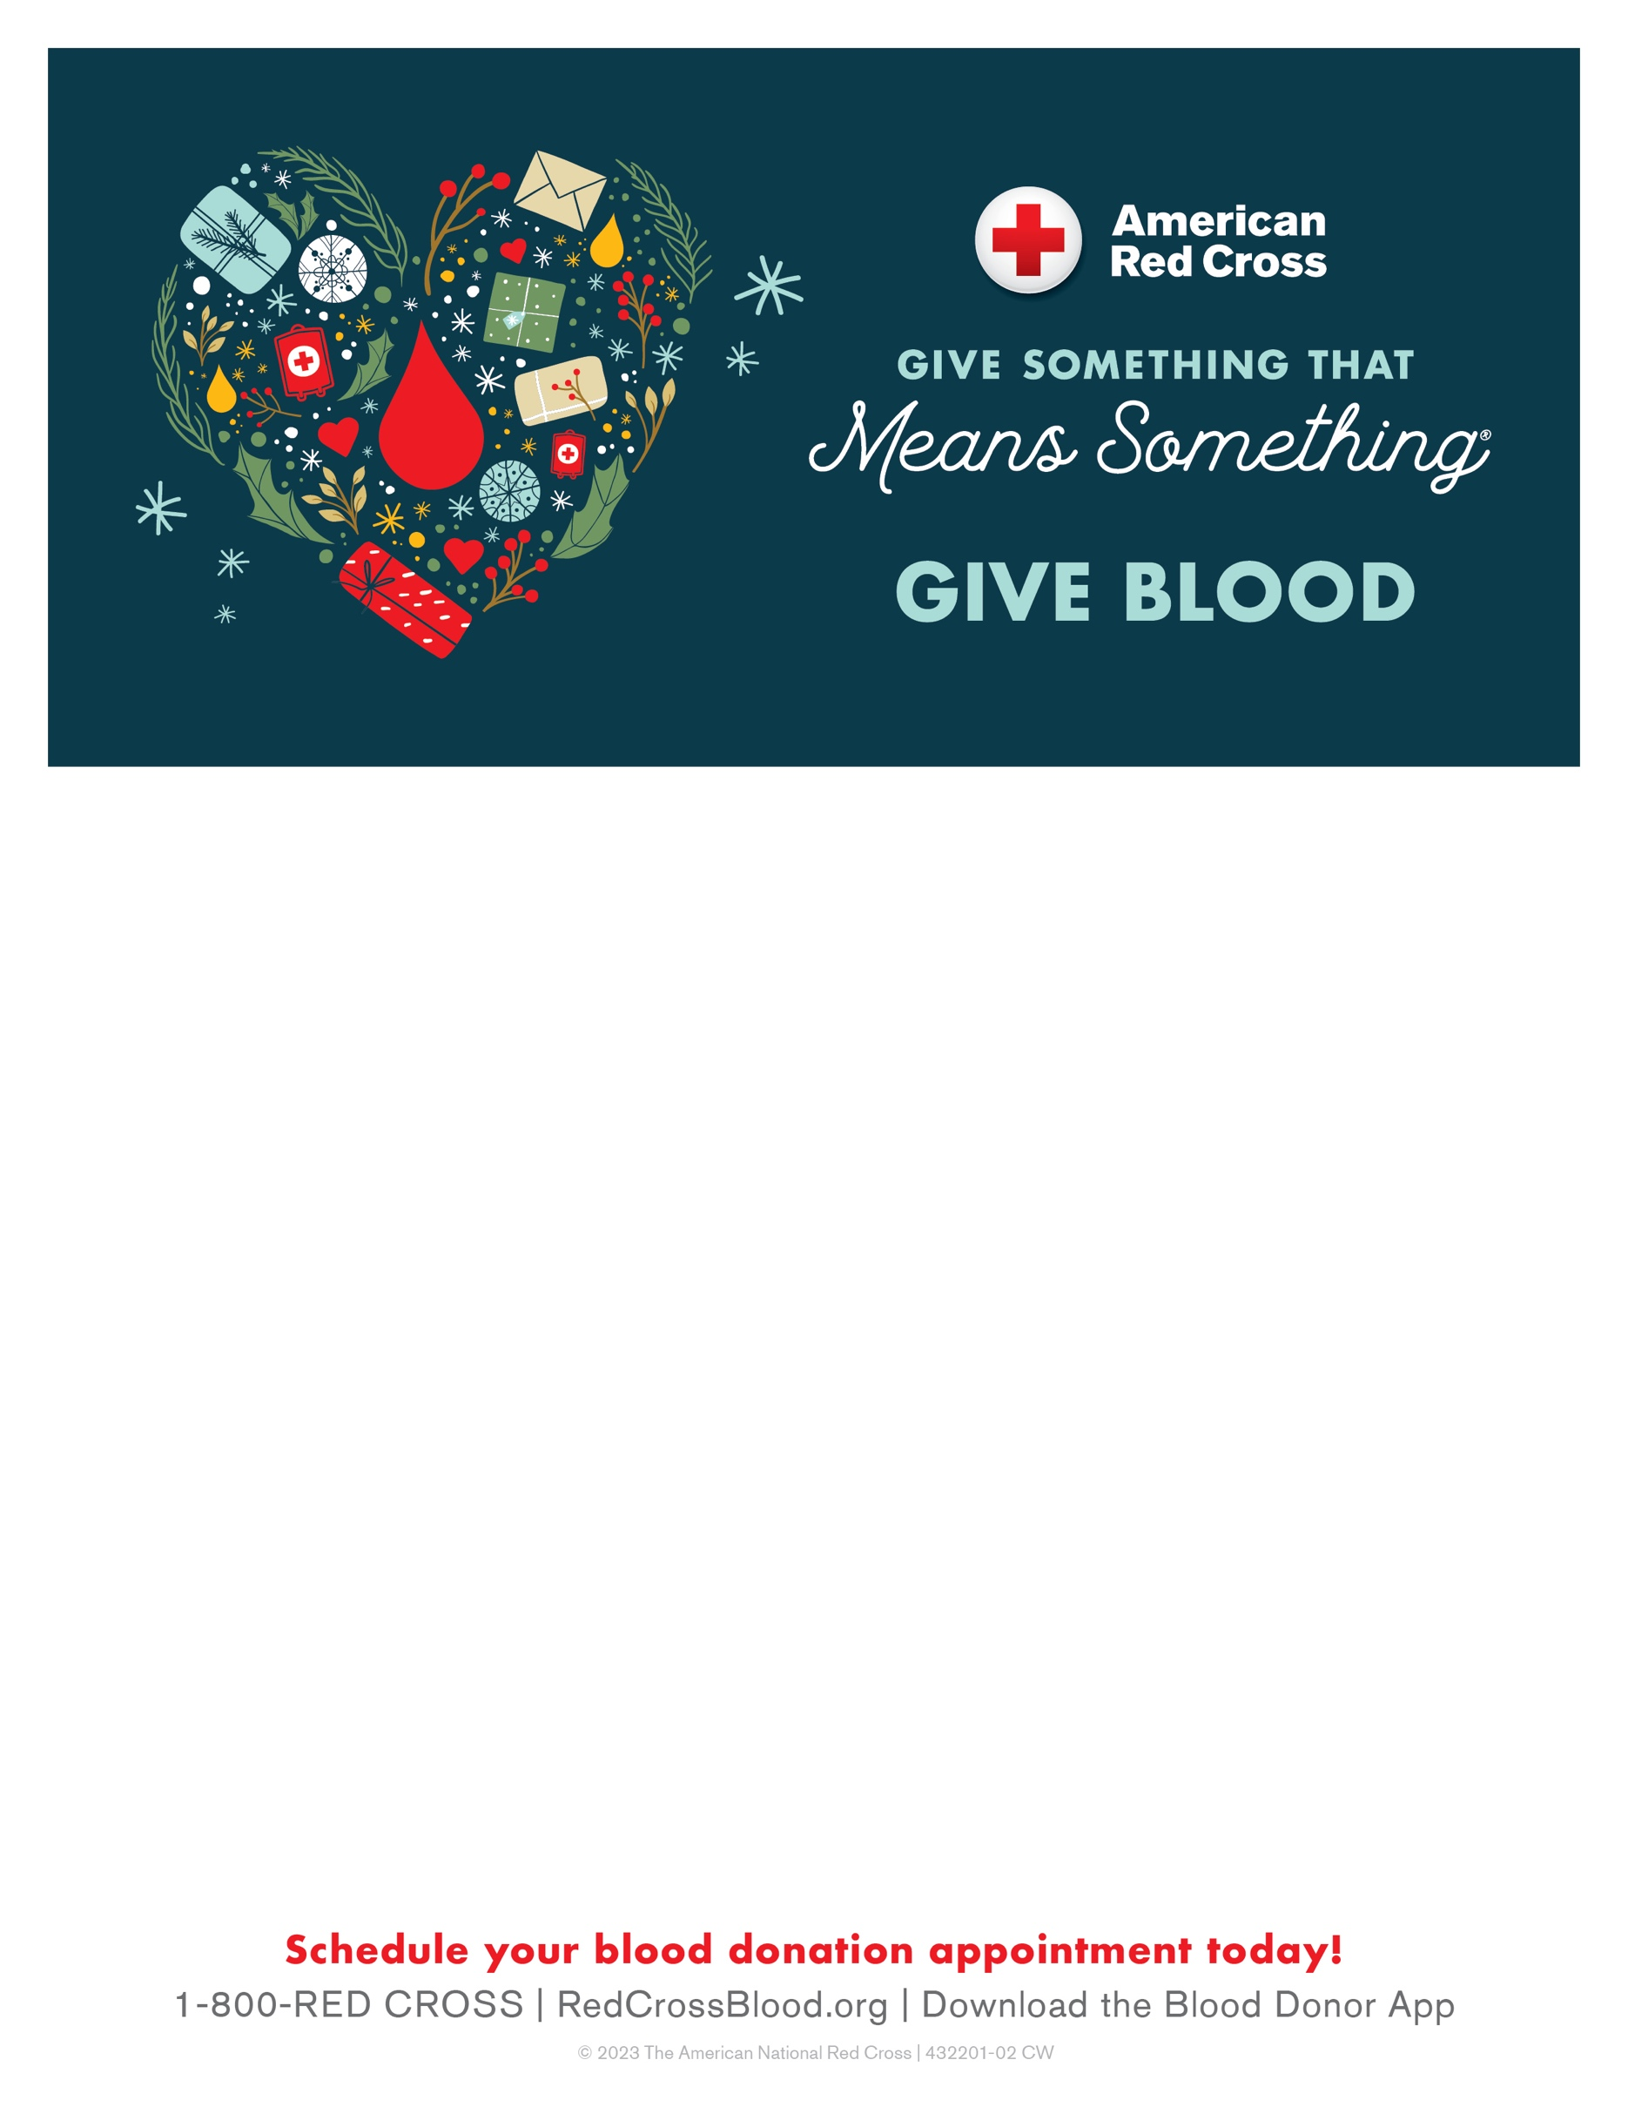

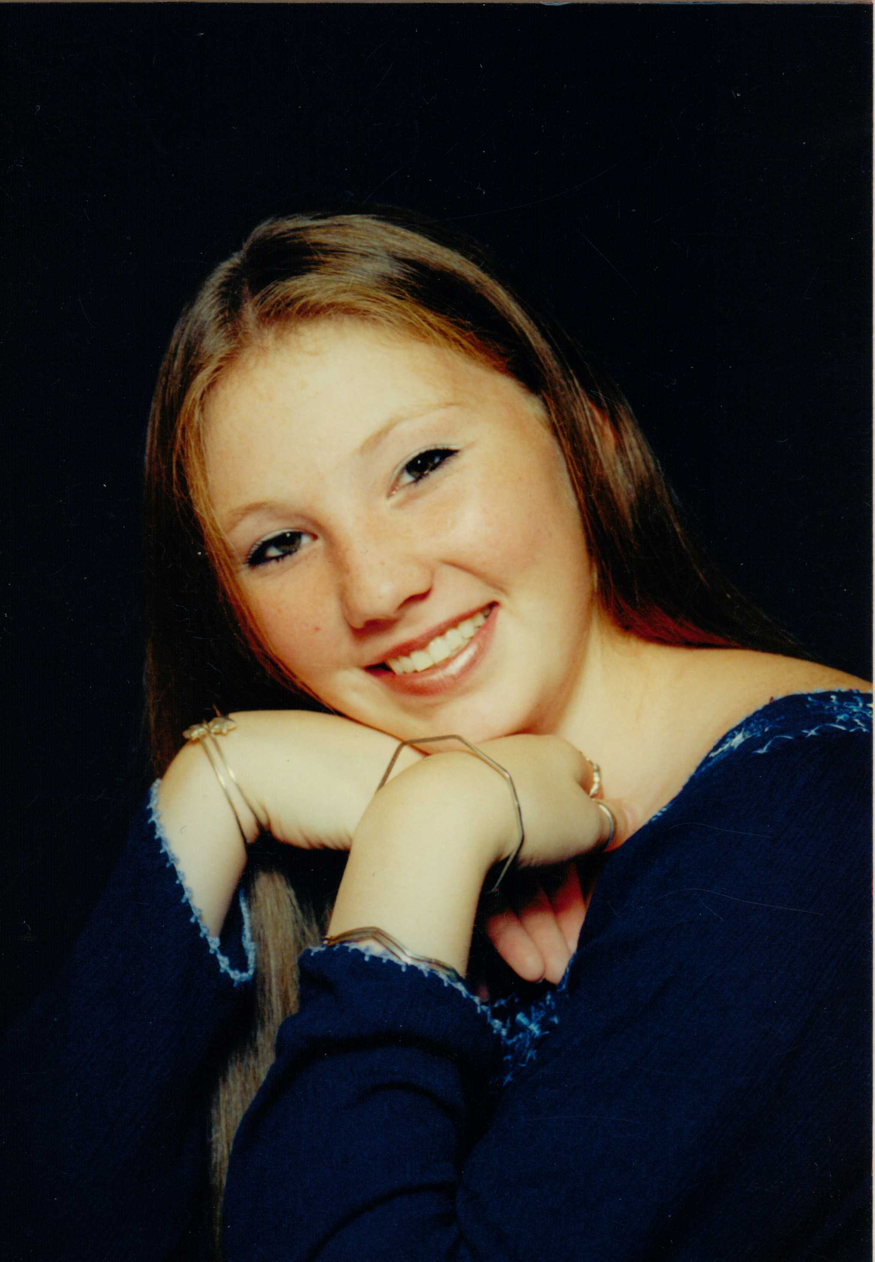

St Mary's of the Lake Blood Drive

In Memory of Liz Amisano

In the Parish Center Gym

10th Street Watkins Glen, NY

Thursday, December 28th

1:00 PM to 6:00 PM

Please call 1-800-REDCROSS or visit redcrossblood.org to

make your life saving appointment.

Free long-sleeve Red Cross T-shirt when you come to donate (while supplies last)

Donors will also be automatically be entered to win one of 12 holiday prize packages!^^ Each package includes a $1,000 Amazon.com Gift Card\*\* and a 65-inch Omni QLED Series Amazon Fire TV.